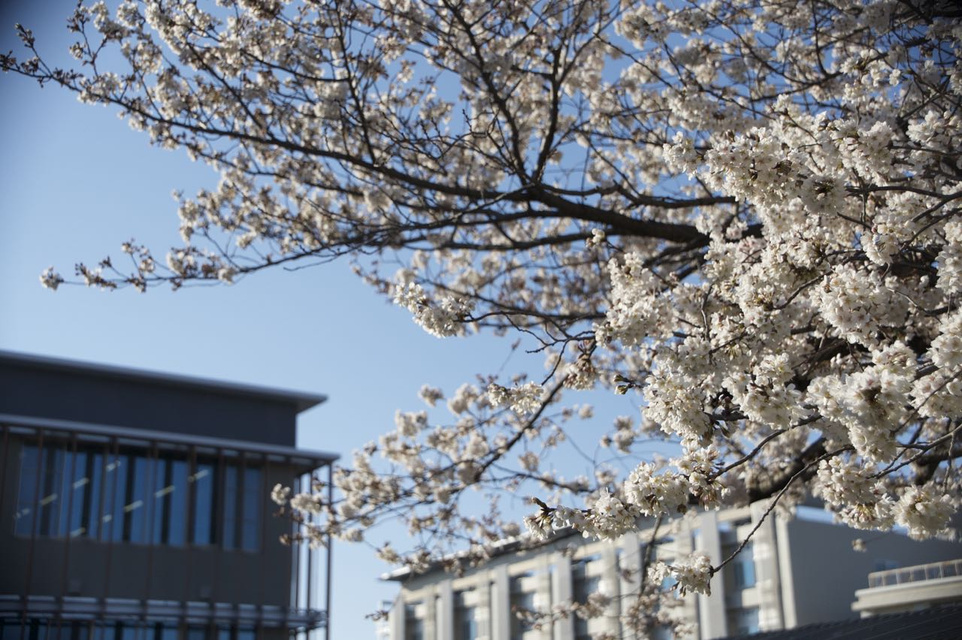**s**



September 28-30, 2015, Hamamatsu, JAPAN

**14th International Conference on Global Research and Education INTER-ACADEMIA 2015**

**Conference Focus**

The International Conference on Global Research and Education, Inter-Academia 2015 is the continuation of the thriving event series organized by the Inter-Academia community every autumn since 2002. These conferences serve as foot-stones of the international scientific network promoting Inter-Academia philosophy and the academic and social interactions among professors, researchers, and students of the leading Shizuoka University and that of the European member universities from Eastern-Central and Eastern Europe.

The main goals of Inter-Academia 2015 are to provide a well set up international forum to review, stimulate, and understand the progress in basic and applied research as well as in educational programs and experiences in training of students. Besides devoting interest on the state-of-the-art and recent results of the participants in the research fields of the community and on the introduction of the participant’s local research communities and main research partners we hope that the conference will contribute to new theoretical and practical achievements in the fields with a special emphasis on new methods for improving the quality of life and that how engineers can contribute to achieve a better life.

A special session for young researchers and students will be organized during Inter-Academia 2015 to offer them the possibility to present their research topics either in short oral presentations and posters. Five best presentations of young researchers will be awarded during the conference.

若手award？

**Conference Topics**

1. Material science and technology, smart materials
2. Nanotechnology and nanometrology
3. Biotechnology and environmental engineering
4. Plasma physics
5. Photonics
6. Manufacturing technology
7. Signal and Image processing
8. Electric and Electronic engineering
9. Measurement, identification, and control
10. Intelligent and soft computing techniques
11. Modeling and diagnostics
12. Robotics
13. Precision engineering
14. Internet based education, distance learning
15. Multimedia and E-learning techniques and materials

**Honorary Committee:**

**Host Rector**

* Yukihiro Ito, Shizuoka University, Japan

**and Rectors**

* Leonids Ribickis, Riga Technical University, Latvia
* Jan Szmidt , Warsaw University of Technology, Poland
* Vasile Isan, Alexandru Ioan Cuza University, Romania
* Gábor Péceli, Budapest University of Technology and Economics, Hungary
* Lambert T. Koch, University of Wuppertal, Germany
* Karol Mičieta, Comenius University, Slovakia
* Mikuláš Bek, Masaryk University, Czech Republic
* Aleksandr V. Rogachev, Gomel State University, Belarus
* Imre Rudas, Óbuda University, Hungary
* Leonid V. Hubersky, Taras Shevchenko National University of Kyiv, Ukraine

**General Chair:**

• Masaaki Nagatsu, Shizuoka University, Japan

要りますか？

**~~Co-Chair:~~**

•

**Executive Committee:**

* Annamária R. Várkonyi-Kóczy (Óbuda University, Hungary)
* Arturs Medvids (Riga Technical University, Latvia)
* Dariusz Korzec (University of Wuppertal, Germany)
* Dumitru Luca (Alexandru Ioan Cuza University, Romania)
* Evgenia Benova (Sofia University, Bulgaria )
* Gheorghe Popa (Alexandru Ioan Cuza University, Romania)
* Hidenori Mimura (Shizuoka University, Japan)
* Hiroshi Mizuta (University of Southampton, England)
* Jürgen Engeman (University of Wuppertal, Germany)
* Kenji Murakami (Shizuoka University, Japan)
* Leonid Poperenko (Taras Shevchenko National University of Kyiv, Ukraine)
* Leszek Kudla (Warsaw University of Technology, Poland)
* Lucel Sirghi (Alexandru Ioan Cuza University, Romania)
* Masaaki Nagatsu (Shizuoka University, Japan)
* Masashi Kando (Prof. Emeritus-Shizuoka University, Japan)
* Michiharu Tabe (Shizuoka University, Japan)
* Nicoleta Dumitrascu (Alexandru Ioan Cuza University, Romania)
* Nobuyuki Araki (Prof. Emeritus-Shizuoka University, Japan)
* Noriko Matsuda (Shizuoka University, Japan)
* Péter Korondi (Budapest University of Technology and Economics, Hungary)
* Ryszard Jablonski (Warsaw University of Technology, Poland)
* Sergei Khakhomov (Gomel State University, Belarus)
* Stefan Matejcik (Comenius University, Slovakia)
* Valdis Kokars (Riga Technical University, Latvia)

**Local Organizing Committee:**

• Masaaki Nagatsu, Michiharu Tabe, Kenji Murakami, Yoshimasa Kawata, Yuko Ryan,

Masaru Shimomura, Norihisa Hiromoto, Kazuhiko Hara, Hiroya Ikeda and Jun Kondoh

担当者会議メンバー（教員）を入れてありますが

**~~Programme Committee:~~**

~~•Andris Ozols (Chairman of Programme Committee, Riga Technical University, Latvia)~~

~~•Alfonsas Grigonis (Kaunas University of Technology, Lithuania)~~

~~•Andris Sternbergs (University of Latvia, Latvia)~~

~~•Dagnija Loca (Riga Technical University, Latvia)~~

~~•Enn Mellikov (Tallinn University of Technology, Estonia)~~

~~•Gundars Mezinskis (Riga Technical University, Latvia)~~

~~•Igor Dmitruk (Kyiv Taras Shevchenko University, Ukraine)~~

~~•Jevgenijs Kaupužs (University of Liepaja, Latvia)~~

~~•Jurijs Dehtjars (Riga Technical University, Latvia)~~

~~•Maris Knite (Riga Technical University, Latvia)~~

~~•Nerija Žurauskienė (State research institute Center for Physical Sciences and Technology, Lithuania)~~

~~•Steponas Asmontas (State research institute Center for Physical Sciences and Technology, Lithuania)~~

~~•Talivaldis Puritis (Riga Technical University, Latvia)~~

Program Committee必要ですか？

**Call for papers**

The authors are invited to submit the abstract within 300 words using the template available on the conference website until June 12. The extended abstract (the summary, introduction, body text, conclusions and a list of references) should be submitted by July 24.

アブストラクトの提出について書きましたが確認ください

**Proceedings**

All accepted papers will be published in the International Journal of JJAP-Japanese Journal of Applied Physics-Conference Proceedings, (~~which is indexed by EI Compendex)~~ and is available in full text online at http://iopscience.iop.org/1347-4065/

Proceedingsについて書きましたが確認ください

**Special Session**

A special session for young researchers and students will be organized during Inter Academia 2015 to offer them the possibility to present their research topics either in short (5 minutes) oral presentations and posters. Five best presentations of young researchers will be awarded during the conference.

~~A limited number of students will be supported by the Organizating Committee~~.

若手award？　サポート？

**Important dates**

|  |  |
| --- | --- |
| Submission of abstract | June 12,2015 |
| Notification of acceptance | July 10,2015 |
| Registration deadline |  |
| Submission of extended abstract | July 24,2015 |
| Submission of camera ready manuscript |  |
| Conference dates | September 28 - 30 |

Registration deadline？　Manuscript？

**Registration fees**

|  |  |
| --- | --- |
| Participants* | ￥50,000 |
| Students* | ￥40,000 |
| Accompanying persons** |  |

* The fee includes: participation in the conference, conference proceedings, lunches, coffee and tea breaks, welcome party and conference dinner, excursions

** The fee includes: welcome party, lunches, conference dinner, excursions

Accompanyあり？

**Payment**

Please make the payment of the registration fee in cash at the registration desk.

**How to reach the venue**

The conference will be held at Congress Center in Hamamatsu ACT CITY. It is located very close to JR Hamamatsu station about 10 minute walk.

**Conference language - English**

**Contacts:** Prof. Masaaki Nagatsu

Graduate School of Science and Technology

Shizuoka University

e-mail: [interacademia@adb.shizuoka.ac.jp](mailto:interacademia@adb.shizuoka.ac.jp)

Contact これでいいですか？